Aim:To perform translation by moving an image from one position to another using OpenCV.

Algorithm:
- Load the input image using cv2.imread().
- Define the translation distances (tx, ty) for shifting the image.
- Create the 2×3 translation matrix using these values.
- Apply the translation using cv2.warpAffine().
- Display the original and translated images.
code:import cv2
import numpy as np
from google.colab.patches import cv2_imshow
img = cv2.imread("Screenshot 2025-11-29 143312.png") # change to your file name
cv2_imshow(img)

tx = 100 # move right
ty = 50 # move down
T = np.float32([[1, 0, tx],
[0, 1, ty]])

moved_img = cv2.warpAffine(img, T, (img.shape[1], img.shape[0]))
cv2_imshow(moved_img)

Input :
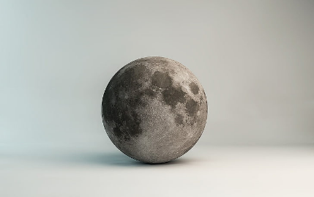
Output:
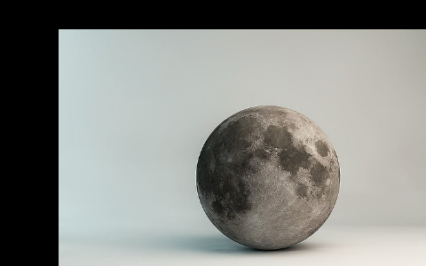
Result :The input image was successfully translated to a new position using the translation matrix.
The shifted image was displayed, showing the movement clearly.

